**KALYANI GOVERNMENT ENGINEERING COLLEGE**

College Road, University Of Kalyani, Kalyani, West Bengal 741235





**KGEC ROBOTICS SOCIETY**

**TOPIC : RFID ATTENDANCE SYSTEM**

**Name :** Sayantan Basak

**Mentor :** Priyanka Gorai

**Domain :** Electronics and IOT

**Date of Submission :** 16.07.25

**DECLARATION**

I hereby declare that the project report entitled "RFID Attendance System" submitted by me to Kalyani Government Engineering College Robotics Society, Nadia, West Bengal, in partial fulfillment of the requirement for being an intern, is a record of bonafide project work carried out by me under the guidance of my senior, mentor Priyanka Gorai Di. I further declare that the work reported in this project has not been submitted and will not be submitted, either in part or in full, for the award of any other Project showcase or any other similar Programs.

Kalyani, Nadia

Dated: 16.07.25 Signature of Candidate

(Sayantan Basak)

**CERTIFICATE OF APPROVAL**

**KGEC Robotics Society**

This is to certify that Mr. Sayantan Basak, an intern at KGEC Robotics Society of B. Tech in Electronics and Communication Engineering of this institution has successfully completed the PROJECT on "RFID Attendance System", under my guidance and supervision and has given a satisfactory account of it in this report.

____________________

(Priyanka Gorai)

(Mentor, KGEC Robotics Society)

**ACKNOWLEDGEMENT**

I would like to express my special thanks of gratitude to my senior, mentor Priyanka Gorai Di for her able guidance and support in completing my Project. I would also like to extend my gratitude to our Principal, Dr. Sourav Kumar Das Sir for providing me and our Robotics Society with all the facilities that were required

With regards,

Sayantan Basak

Dated : 20.26.25

**CONTENTS**

* Executive Summary
* Introduction
* Components Used
* Working Principle
* Circuit
* Application
* Conclusion
* References

**EXECUTIVE SUMMARY**

This project presents an RFID-based Attendance System with an LCD Screen designed to streamline and automate the process of attendance recording in educational institutions, offices, and other organizations. The system utilizes Radio Frequency Identification (RFID) technology to uniquely identify individuals through RFID cards or tags, significantly reducing manual errors and saving time.

Upon scanning an RFID card, the system reads the unique ID and cross-verifies it with a pre-registered database. A 16x2 LCD screen displays the user's name or ID and confirms whether the attendance has been successfully recorded.

The entire process is **contactless, fast, and secure**, ensuring hygienic operation and improved efficiency. The system can be customized further for integration with **Excel reports**, **cloud databases**, or even **SMS/email alerts**.

This RFID Attendance System offers a cost-effective and scalable solution for organizations aiming to modernize their attendance management processes with enhanced transparency and real-time monitoring.

**INTRODUCTION**

Maintaining accurate attendance records is essential in educational institutions, offices, and other organizations. Traditional methods like manual registers or roll calls are time-consuming, prone to errors, and difficult to manage for large groups. With the advancement of technology, automation has become the key to improving efficiency in such administrative tasks.

This project introduces an **RFID-based Attendance System** integrated with an **LCD screen**, which provides a fast, contactless, and reliable method for recording attendance. **Radio Frequency Identification (RFID)** technology is used to identify individuals based on the unique code stored in RFID cards or tags. When a card is scanned, the system identifies the individual, logs the attendance along with date and time (using an RTC module), and displays relevant information on an LCD screen.

The system is user-friendly, cost-effective, and easily scalable. It reduces human intervention, minimizes errors, and offers real-time feedback and record-keeping capabilities. This makes it an ideal solution for modern attendance tracking needs in schools, colleges, workplaces, and secure facilities.

**COMPONENTS USED :**

The following hardware components were used to build the RFID Attendance System with LCD display:

**1. RFID Reader (RC522)**

* Used to read the unique ID from RFID cards or tags.
* Operates at 13.56 MHz.
* Communicates with Arduino via SPI protocol.

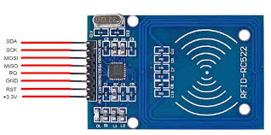

**2. RFID Tags/Cards**

* Each card contains a unique 12-digit UID.
* Used by individuals to mark their attendance.

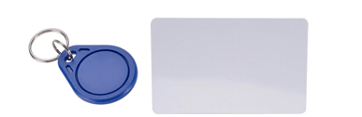

**3. Arduino Uno**

* Acts as the main controller of the system.
* Receives data from the RFID reader and processes it.
* Controls the LCD display and handles logic operations.

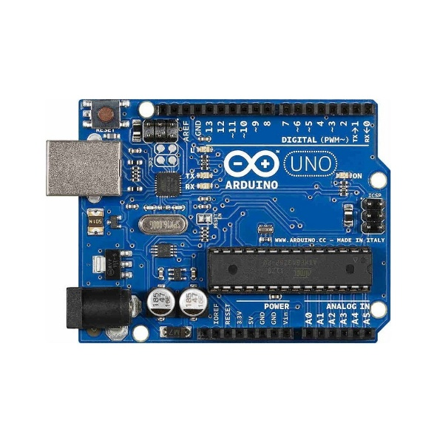

**4. 16x2 LCD Display (with I2C Module)**

* Displays messages like "Attendance Marked", UID, or name.
* I2C module reduces the number of required pins (only 2: SDA & SCL).

Additionally, jumper wires, power supply, Arduino cable, etc were used

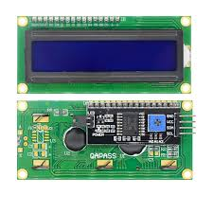

**Jumper wires :** Male to Female

**WORKING PRINCIPLE**

The **RFID Attendance System** operates based on the principle of **radio frequency communication** between an RFID card and an RFID reader. Here's how the system works step-by-step:

1. **Card Scanning**  
   When a user places their RFID card or tag near the **RC522 RFID reader**, it detects and reads the card’s **unique identification number (UID)** using radio waves.
2. **Data Processing**  
   The **Arduino Uno** receives the UID via the SPI communication interface. It compares the UID with the list of pre-registered IDs stored in the system.
3. **Attendance Logging**
   * If the UID matches a registered user, the system marks attendance and captures the **current date and time** using an RTC (if connected).
   * The LCD then displays a confirmation message like “Attendance Marked” along with the UID or name.
4. **Invalid Entry Handling**  
   If an unregistered UID is detected, the system displays “Access Denied” or “Unknown Card” on the LCD.

**CIRCUIT**

**Pin connections of RFID Card reader RC522 with Arduino Uno:**

Pin -> RFID -> UNO  
1      -> 3.3V   ->  3.3V  
2      -> RST   ->  9  
3      -> GND  ->  GND  
4      -> IRQ    ->  EMPTY  
5      -> MISO  -> 12  
6      -> MOSI  -> 11  
7      -> SCK    -> 13  
8      -> SDA    -> 10

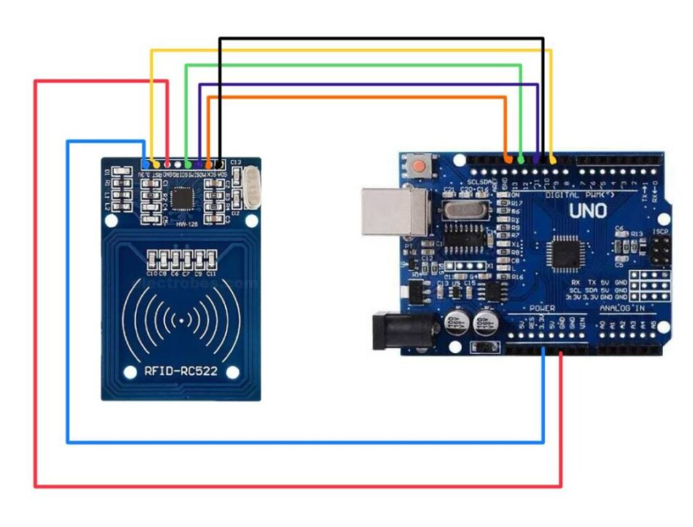

**Pin Connections of Arduino Uno to 16 X 2 LCD display with I2C module:**

| **LCD (I2C Module Pin)** | **Arduino Uno Pin** |
| --- | --- |
| VCC | 5V |
| GND | GND |
| SDA | A4 |
| SCL | A5 |

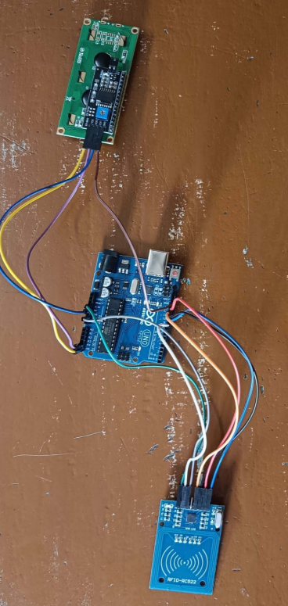

Circuit of RFID Attendance System Project

**APPLICATIONS**

**1. Educational Institutions**

* Schools, colleges, and universities for student attendance.
* Staff and faculty check-in/check-out monitoring.

**2. Offices and Corporates**

* Employee attendance tracking.
* Entry/exit time logging and work-hour calculation.

**3. Hospitals**

* Staff shift monitoring.
* Access control in restricted areas.

**4. Industrial Workplaces**

* Worker attendance in factories and construction sites.
* Integration with payroll systems.

**5. Government and Administrative Offices**

* Secure and transparent attendance management.
* Visitor tracking and record maintenance.

**6. Residential Societies**

* Entry logging for residents, guests, and domestic helpers.

**7. Security and Access Control**

* Access permission in secure buildings or rooms.
* Integration with doors or gates using relays or locks.

**8. Transport and Fleet Management**

* Bus/train staff check-in system.
* School bus student tracking system.

Restrictions :

Note : Only RFID Cards should be used for the project . If the card is not RFID then RC522 will not be able to detect it.

**CONCLUSION**

The RFID Attendance System with LCD screen offers an efficient, contactless, and reliable solution for managing attendance in educational institutions, workplaces, and other organizations. By utilizing **RFID technology**, **Arduino Uno**, and an **I2C-based LCD display**, the system simplifies the process of identifying individuals and recording their attendance in real-time.

The project successfully demonstrates how automation can replace traditional manual methods, reducing human error, saving time, and ensuring greater accuracy. The use of an LCD provides immediate visual feedback, enhancing user interaction. With further enhancements like database storage or network integration, the system can be scaled and adapted to meet larger and more complex attendance management needs.

This project is a step toward building smarter and more secure access control and tracking systems using affordable and accessible microcontroller technology.

**REFERENCES**

* **Arduino Official Website**  
  <https://www.arduino.cc>  
  *(For Arduino Uno technical specifications and programming resources)*
* **MFRC522 RFID Module Datasheet**  
  https://www.nxp.com/docs/en/data-sheet/MFRC522.pdf  
  *(For understanding RFID communication and pin configuration)*
* **LiquidCrystal_I2C Library – GitHub Repository**  
  <https://github.com/johnrickman/LiquidCrystal_I2C>  
  *(For interfacing LCD with I2C and Arduino)*
* **DS1307 RTC Module Datasheet**  
  https://datasheets.maximintegrated.com/en/ds/DS1307.pdf  
  *(For Real-Time Clock integration)*
* Youtube : <https://youtu.be/u6aMWzVIBWo?si=-a-EtZZV6PvKvCuF>